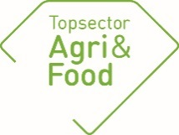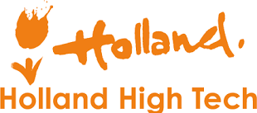

General Information
PPP-number | AF-16191
Title | DISAC - Data Intensive Smart Agrifood Chains
Theme | HT2FtW/Slimme technologieën (cross over Agrifood en HTSM)
Knowledge institutes | WR, TNO, NLR
Project leader (naam + emailadres) | Corné Kempenaar (corne.kempenaar@wur.nl) 2e contact Bert Philipsen (bert.philipsen@wur.nl)
Contact porson (on behalf private companies) | Geert Hermans (geert.hermans@zlto.nl)
Contactperson government | Gertjan Fonk (g.fonk@minez.nl), Frans Lips (f.lips@minlnv.nl)
Total project budget (M€) | 4,32 (o.b.v. update werkplan 2019)
Adress projectwebsite | https://subsites.wur.nl/nl/plb/PL-Projecten/DISAC.htm  KOL: https://www.wur.nl/nl/Onderzoek-Resultaten/Onderzoeksprojecten-LNV/Expertisegebieden/kennisonline/Data-Intensive-Smart-Agrifood-Chains.htm
Start date | 1 januari 2017
End date | 31 december 2020

Approval by contact person (penvoerder)/consortium

Approval report by PPP contact person companies | X Approved  not approved

Planning and progress
PPP R&D according to plan | Yes
Any changes in PPP consortium? | No
Any delay foreseen? | In 2018 we were behind schedule with activities and results in the DISAC subprojects E-Pieper and Connectivity. In 2019 we took away a large part of the legging behind. Still we asked for some NAPRO for activities to be done in 2020. We have planned to meet most of the activities scheduled in DISAC by end of 2020. We only see delay for the final report of DISAC (cannot be ready before December 31, 2020).
If there are substantive bottlenecks, give a short description | No
Is there deviation from the budget / budget used? | No

Description of the PPP work

DISAC is the abbreviation of the English PPP title: Data Intensive Smart Agrifood Chains. The focus in the PPP is on smart farming R&D for arable and dairy production chains.

The aim of DISAC is to improve the economic and ecological sustainability of important Dutch agri-food chains through the introduction of innovative technologies (IoT / sensors, data analytics,) through a 4-year public-private R & D program with multiple use cases. better crop and chain management with as much real-time and object-specific information as possible, innovative data infrastructures and big data analyzes. DISAC has 3 subprojects: N-Sensing, E-Pieper and Connectivity.

DISAC contributes to: (1) higher yields and / or quality of products, (2) less use of energy, water and agro-chemicals, (3) less environmental impact and better mineral utilization, (4) more efficient and transparent chains, and ( 5) new products and services that can be deployed nationally and internationally.

For more information, please refer to the DISAC project plan as included in the consortium agreement of the PPP. See also https://www.wur.nl/nl/project/Slim-verzamelen-van-data-leidt-tot-duurzamere- aardappel-en-grasproductie.htm. Organization of the project and partners are shown in scheme and picture below.

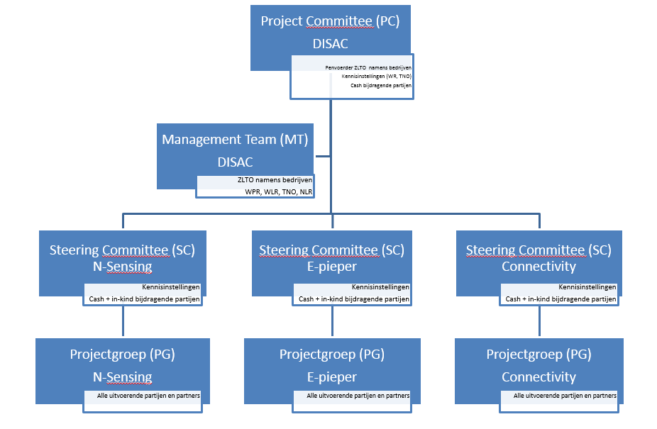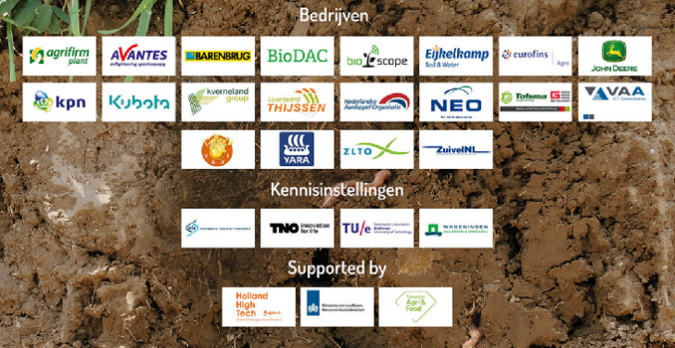

Results 2019
DISAC is a topsectors cross over PPP with tasks divided over three sub projects. WR is leading the sub projects, but tasks were assigned to other knowledge institutes as well. For that reason, we summarize results 2019 below per sub project per knowledge institute.
In N-Sensing, the R&D is focused on the development and implementation of a nitrogen / protein advice system for grass, which converts measurements and predictions into practical action perspectives for dairy farmers. Research is being done on sensors for measuring nitrogen in the soil, protein in grass, and models that convert data into usable information for practice. Results 2019 are:
By NLR:
- In 2019 a field campaign has been carried out in which reflection measurements have been collected at six locations during the growing season with an Avantes spectrometer to validate and optimize the atmospheric correction of satellite data from Landsat, Sentinel and SuperView (initially collected and processed by NEO and NLR). The analysis of the validation is in progress and asks additional attention as the accuracy of the reflectance measurements is less than expected;
- A start is made with the development of a methodology in which all collected remote sensing observations (satellite and when available drone) and field measurements are translated to a single integrated and calibrated time series of reflections of the parcels in a defined spatial grid. A number of ideas have been worked out with support of a student and will be worked out further in 2020;
By TNO:
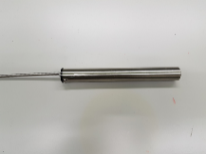
- Based on recommendations from the previous field trial improvements were applied to the optical nitrogen sensor demonstrator. Minor improvements were applied to the nitrate reactive coating. A temperature sensor was integrated into in the system for improved temperature correction of the sensor signal. Improved solar panels were used to improve the lifetime of the battery;
- A new field trail at KTC Zegveld was performed with two separate setups in two fields used for research on the effect of drainage in CO2 emissions in peat land. One setup was in a control field the other in a field with drainage. The sensor data are compared with periodic laboratory measurements. One of the sensors had to be changed after the first month. Different sensors have been used for determining the soil moisture content as well as the dry matter content. At this moment not all data have been processed;
- Publication in ‘Verantwoorde Veehouderij’, March 25, 2019, “Optische sensor TNO meet beschikbare nitraat in de bodem”, https://www.verantwoordeveehouderij.nl/show/Optische-sensor-TNO-meet-beschikbare-nitraat-in-de-bodem-1.htm.
By WR:
- Analyses of the field trial (2016-2017) focused on growth modelling, grass height and reflection measurements made clear that growth modelling gave the best yield prediction and improved when modelling was combined with reflection measurements or grass height. Nitrogen content of grass appeared to be difficult to measure and predict.
- Test of prototype Nitrogen / Protein Advice System for grass (web application GrassSignal) on five dairy farms and experimental farm De Marke. Grass modelling resulted mostly in accurate predictions, although relatively large deviations were found for the first cut. It is expected that when modelling is combined with reflection or grass height measurements (based on algorithms of the field trial) predictions will improve substantially.
- The pilot made clear that weekly laboratory analyses of fresh grass to determinate N-content provided a need to monitor N-content. With project partners it will be explored whether a service can be set up and whether this can be linked to GrassSignal.
- An extensive field campaign with detailed reflection measurements (hyper spectral in near infra-red) was carried out in 2018 to gather sufficient ground truth to establish calibration lines between satellite reflections and grass yield (in kg ds) or N content. Calibration lines for dry matter yield appeared to be sufficiently reliable to implement in GrassSignal.
- In 2019 an in-depth analysis of the correlations between the measured nitrogen content (determined by Eurofins) and the spectral reflections of grass was carried out in collaboration with a PhD student from Wageningen University. Unfortunately, it must be concluded that these correlations are not sufficiently reliable to calculate a nitrogen content map from a satellite image or, for example, to develop a measuring instrument that can determine the nitrogen content of grass on site in the field.
- A stable pixel map has been made based on the "cloudy" Sentinel-2 images in Groenmonitor.nl. This only includes the pixels that have a constant reflection during the year and therefore do not change (for example, open water, open sand bodies, large parking spaces, etc.). These stable pixels can be used to calibrate remote sensing images from other satellites so that they are uniform with the Sentinel-2 satellite images.
- Progress meeting reports 2019 (minutes and powerpoints) are available.

In E-Pieper, the R&D is focused on bringing together soil, crop, climate and management data on service platform / dashboard of potato growers. Results 2019 are:
By WR:
- Prototype of the dashboard for management of potato crops is made available and was demonstrated;
- A test session with farmers is planned end of February to test and improve the interface.
- Special dashboard session planned on 11 march 2020 to discuss some of the dashboard widgets with the specialists of Tipstar, the potato growth model (Frits van Evert) and Watbal, the waterbalance model, with Idse Hoving.
- On farm testing of service platform and data-driven precision applications during the whole year. Soil, weather, crop and management data are collected, validated and used in precision crop management (irrigation, nutrient application and pest and disease control). Results are discussed within the PPP;
- Project partners have identified data topics which they want to use in services in 2020;
- Progress meeting reports 2019 (minutes and powerpoints) are available.

Connectivity works on the development and / or streamlining of Internet of Things (IoT) technology and Machine to Machine (M2M) communication. Use cases are defined in grassland management (fertilizer application) and arable farming (weed control). Results 2019 are:
By TNO:
- TNO develops a standardised architecture for the information exchange between equipment in the field and farm management information system (FMIS), and also between FMIS and systems of 3rd parties. In 2019 a set of manuals of Kverneland equipment was used to generate a list of keywords which were not yet available in the ISO-XML standard.
By WR:
- On farm experimentation with sensing of soil and grass properties in order to make better task maps for fertilizer use;
- Two field experiments started in which soil and crop properties are measured in order to develop algorithms for precision fertilizer application;
- Drone images of onion crops are made on two different fields on two different days, the 22th of May and the 3th of July. Hereby capturing data during the emerging stage and a later growth stage of the onions. Besides capturing the drone images, the position of weeds in the fields are recorded manually as well using a GPS-pole. The drone captured images on two different heights, to examine the effect of resolution on the weed recognition;
- High resolution, commercial satellite images of the onion field are purchased. Those images have a resolution of 0.4m and 0.8m. Goal is to see if weeds can be recognised on those images;
- Development of algorithms for detection of two annual weed species in drone images of onion crop. Using both the data from 2018 and 2019.
- A procedure to make a task map for spot spraying of weeds in crop is developed, based on the geolocation of weeds. A task map for spot spraying will be tested in 2020.
- Progress meeting reports 2019 (minutes and powerpoints) are available.

Number of products delivered
Scientific papers | Reports | Articles in applied journals | Presentations/workshops
0 | 1 | 14 | 12
Titles/descriptions key results of 2019 (max. 5) and target groups
- The GrassSignal decision support system is available as first prototype and was tested on six dairy farms. It provides information on grass production and quality of the produce (protein content) (N-Sensing sub project).
- TNO published results of R&D on soil nitrate sensor. https://www.verantwoordeveehouderij.nl/show/Optische-sensor-TNO-meet-beschikbare-nitraat-in-de-bodem-1.htm. (N-Sensing sub project).
- The E-Pieper dashboard is available as prototype. The dashboard and Akkerweb potato crop management apps were tested on two farms.
- A large amount of grass production data from field experiments in 2019 (N-Sensing and Connectivity-grass sub projects)
- Algorithms for detection of weeds in drone images of onion crops were developed and used to make a spot spraying task map (Connectivity-arable sub project).
For publications and presentations, see appendix.

Appendix: Titles/descriptions of all products of 2019.

DISAC general
- Websites:
  - https://subsites.wur.nl/nl/plb/Projecten/DISAC.htm
  - https://www.wur.nl/nl/project/Slim-verzamelen-van-data-leidt-tot-duurzamere-aardappel-en-grasproductie.htm.
  - https://www.wur.nl/precisielandbouw (WUR startpagina precisielandbouw)
- Gansevoort, M, 2019. DISAC helpt bij verduurzaming van agrifood ketens. TO2Morrow magazine 2019 p.16-17 (input Kempenaar, Philipsen en van den Akker namens WR, TNO en NLR).
- Philipsen AP, Kempenaar C, 2019. Presentatie PPP DISAC tijdens Netwerkbijeenkomst Precisielandbouw 21 november, te Abbenes. Ca 100 bezoekers.

Project coordination
The DISAC Management Team (MT) had two meetings in 2019, on 13-2-2019 and 25-11-2019.

The DISAC Project Committee (PC) meeting was held on 16-5-2019. We were a guest at the John Deere factory in Zweibrucken, Germany. Prior to the meeting, we were given a very interesting (and impressive) factory tour where the John Deere combines and forage harvesters are assembled.

Project N-Sensing
- Hoving I, Holshof G, 2019. Grasgroei meten of grasgroei voorspellen? In V-focus, januari-nr.
- Contribution to Gras-en mais manifestatie on experimental farm Vredepeel September 5, 2019
- Hoving I, 2020. Presentation on international symposium about remote sensing technics. organised by Nederlandse Vereniging voor Weide en Voederbouw (NVWV) in Kleve Germany
- Philipsen AP, Hoving I, 2020. Presentation GrasgroeiVoorspelling on symposium TOPKUIL, 7 november 2019, Oosterwolde.
- Philipsen AP, Hoving I, 2020. Presentation GrasgroeiVoorspelling on AgroTechniek Assen, 11 december 2019, Oosterwolde.
- Hoving I, Philipsen AP, 2020. Presentation GrasgroeiVoorspelling on Amazing Grazing, 18 december 2019, Brummen.
- Hoving, I.E., J. van Riel, G. Holshof, M. Plomp, S. Agricola, K. van Boheemen en G. Roerink, 2019. Schatten van grasopbrengst op basis van spectrale reflectie, grashoogte en modellering; Onderzoeksresultaten van een maaiproef op zand- klei en veengrond 2016-2017. Wageningen Livestock Research, Report 1200. https://doi.org/10.18174/508117 .
- Newsitem Website: 28 februari 2019 - In de projecten ‘Amazing Grazing’ en ‘Precisie landbouw 2.0’ wordt gekeken naar het modelmatig schatten van de actuele grasopbrengst en het voorspellen van de groei in de komende dagen. Lees hier volledige artikel: Grasgroei meten of voorspellen.
- Newsitem Website: 25 maart 2019 - Binnen het project Amazing Grazing is een methode ontwikkeld om de dagelijkse en wekelijks grasgroei te voorspellen. Lees hier volledige artikel: Praktijktoets Grasgroeivoorspelling.
- Newsitem Website: 25 maart 2019 - In het project N-sensing heeft TNO een nitraatsensor ontwikkeld en deze is getest. De eerste testresultaten lijken perspectief te bieden voor monitoring van de actuele mineralisatie van stikstof. Lees het hele artikel: Optische sensor TNO meet beschikbare nitraat in bodem.
- Newsitem Website: 11 juli 2019 - Stand van zaken rondom praktijktoets Grasgroeivoorspelling binnen het project Amazing Grazing. Lees hier het volledige artikel: Stand van zaken praktijktoets Grasgroeivoorspelling.
- Opendag Dag van de Wetenschap 5 oktober 2019, Dairy Campus Leeuwarden (zie foto).

Project E-Pieper
- Presentation; 20-22 augustus 2019 velddagen in kader NPPL, resultaten DISAC en e-pieper, in Hoek, Slootdorp en Vierhuizen. Ca 100 bezoekers per velddag.
- Presentation: E-pieper en connectivity (akkerbouw), tijdens praktijkdag in Dronten voor NPPL. 4 juni 2019. Ruim 90 bezoekers.
- Newsitem Website: Been Th, Eerste dashboard E-Pieper ziet levenslicht, gepubliceerd op 9 november 2019.
- Newsitem Website: Rapport Wageningen Plant Research 2018: Sensoren en gewasmodellen voor precisielandbouw: Literatuuronderzoek DISAC deelproject E-pieper.
- Newsitem Website: TNO rapport: Programma van Eisen (PvE) voor de data infrastructuur van E-pieper (2018).
- Newsitem Website: TNO Prestentatie: DISAC - E-pieper: Architectuurkeuzes.

Project Connectivity
- Anoniem 24 september 2019, Nieuwe Oogst: Een derde minder kunstmest nodig!
- C. Lokhorst, J. Oenema, 2019. Strategieën precisiebemesting op gras. V-Focus juni 2019. p18-20.
- K. van Boheemen, 2019. Precision fertilization on grassland(?); Using new technologies to optimize grassland systems. Presentation on international symposium about remote sensing technics organised by Nederlandse Vereniging voor Weide en Voederbouw (NVWV) in Kleve Germany, 18 September 2019.
- Idse Hoving en Jouke Oenema, 2019. Sensorgestuurde grasteelt. Presentatie voor de Nederlandse Bodemkundige Vereniging (NBV), Reusel, 28 juni 2019.
- Newsitem Website: Oenema J, Grasland dynamisch bemesten vraagt om meer onderzoek, gepubliceerd op 20 december 2019.
- Newsitem Website: TNO, Van den Akker E, Digitalisering in de akkerbouw gepubliceerd op 29 oktober 2019 (ism Kvernerland).
- Video: Digitalisering in de akkerbouw, TNO ism Kverneland, oktober 2019.

