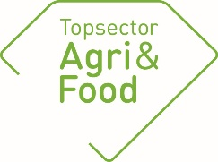

General information
PPP-number | TKI-AF-17005
Title | Breaking habits for the better: behavioural change towards more sustainable foods
Theme | Consument & Maatschappij
Implementing institute | Wageningen Food & Biobased Research
Project leader research (name + e-mail address) | Monique Vingerhoeds  monique.vingerhoeds@wur.nl
Coordinator (on behalf of private partners) | Prof dr Liesbeth Zandstra  Liesbeth.Zandstra@unilever.com
Project-website address | https://www.wur.nl/nl/Onderzoek-Resultaten/Onderzoeksprojecten-LNV/Expertisegebieden/kennisonline/Breaking-habits-for-the-better-behavioral-change-towards-more-sustainable-foods.htm
Start date | 1-1-2018
Final date | 31-12-2020

Approval by the coordinator of the consortium
The annual report must be discussed with the coordinator of the consortium. The “TKI’s” appreciate additional comments concerning the annual report.
Assessment of the report by the coordinator on behalf of the consortium: | X Approved  Not approved
Additional comments concerning the annual report: | No comments by coordinator

Summary of the project
Problem definition | Food choice is largely driven by habits, and habits are difficult to break. This fact hampers the transition of current food choices into a new and preferably more sustainable and healthy direction. Knowledge about how food habits are formed, and under which circumstances they can be changed is needed in order to help consumers change their diet towards more healthy and sustainable foods.
Project goals | Aim: to develop a validated research method that facilitates the development of new and reformulated (sustainably sourced and produced) food products that can help to radically change existing food habits (e.g. from a meat to a plant-based diet) or generate new food habits (e.g. by replacing regular-salt products with reduced-salt products).

Results
Planned results 2019 | Study 3: Effects of (in-)congruent exposure on sensory perception, liking, several food-surveys, emotions.
Achieved results 2019 | Planned study (3) executed; results analysed.  Study 3 examined the effect of congruency of the setting on sensory perception and liking of products. A beach and a restaurant setting were created in an immersive room. Products examined were sushi (congruent for the restaurant, incongruent for the beach), popsicles (congruent for the beach, incongruent for the restaurant), and ice-tea (congruent for both the beach and the restaurant).  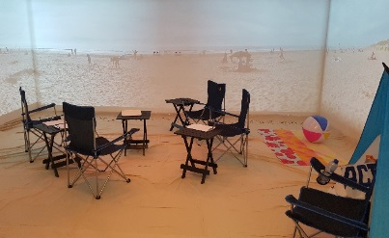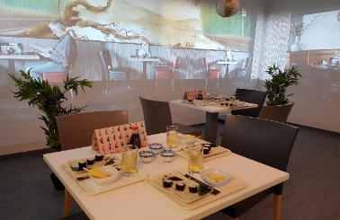  The results showed that liking, desire to eat and attribute ratings varied with the type of immersive context, whereby congruent food-context combinations, such as popsicle at the beach and sushi in the restaurant, triggered more stable responses and stronger desires to eat than incongruent combinations.  Other context effects were not food-specific: foods consumed in the restaurant tended to taste more sweet and sour than the same foods consumed at the beach. Also, desire to eat was in general lower in the restaurant compared to the beach. Some of these effects persisted after the context switch in the eight session (food still tasted sweet when tasted at the beach), other effects were determined by the location (desire to eat sushi).  The results demonstrate that 1) consumption contexts need to be taken into account in consumer tests, and 2) immersive contexts may be a viable alternative for real-life contexts  Papers in preparation.  Further analyses ongoing.
Planned results 2020 | Planning and executing final study (4), including eye-tracking and possibly psychophysiological measurements in a simulated environment.  Analysis of results, writing of papers  Finalising/publishing papers study 3 (including posters/presentations at meetings/conferences).

Deliverables/products in 2019 (provide the titles and /or a brief description of the products/deliverables or a link to a website.
Scientific articles:
De Wijk R.A., Kaneko D. ,Dijksterhuis G.B., van Zoggel M, Schiona I, Vasilli, M., Zandstra E.H., (2019). Food perception and emotion measured over time: in-lab and in-home, Food Quality and Preference 75, 170-178.
Papers in preparation/submitted:
De Wijk R.A., Kaneko D. ,Dijksterhuis G.B., van Bergen,G. , Zandstra E.H. (2019). Sushi at the beach: The effects of immersive beach and restaurant contexts on food evaluations.
Zandstra EH , Kaneko D , Dijksterhuis GB, Vennik E , De Wijk RA.. Implementing immersive technologies in consumer testing: taste perception and liking in a laboratory, immersive simulated café and real café.
De Wijk, R.A., Kaneko, D., M., Zandstra E.H., Dijksterhuis, G.B. (2019). Effects of eating context on food perception are not caused by the eating location itself.

External reports:

Articles in professional journals/magazines:

(Poster) presentations at workshops, seminars, or symposia.
Dijksterhuis G.B., Kaneko D., De Wijk R.A., van Zoggel M., Schiona I., Zandstra E.H. (2019). Effects of eating context on food perception are not caused by the eating location itself. Pangborn Sensory Science Symposium, 28 July – 1 August 2019, Edinburgh, Scotland. Poster
De Wijk RA, Kaneko D, Dijksterhuis GB, van Zoggel M, Schiona I, Vasilli M & Zandstra EH. (2019). Food perception and emotion measured over time in-lab and in-home. Pangborn Sensory Science Symposium, 28 July – 1 August 2019, Edinburgh, Scotland. Poster
Zandstra EH, Kaneko D, Dijksterhuis GB, Vennik E, De Wijk RA. (2019). Implementing immersive technologies in consumer testing: Taste perception and liking in a laboratory, immersive simulated café and real café. Pangborn Sensory Science Symposium, 28 July – 1 August 2019, Edinburgh, Scotland. Poster

TV/ radio / social media / newspaper:
https://topsectoragrifood.nl/nieuws/pps-project-onderzoekt-effect-omgeving-op-voedselgewoonten/
https://www.foodvalley.nl/news/kikkoman-takes-a-collaborative-approach-to-business-in-europe/

Remaining deliverables (techniques, devices, methods, etc.):
Skills to simulate (food)situations allowing measurements in the WFBR Experience Room.

