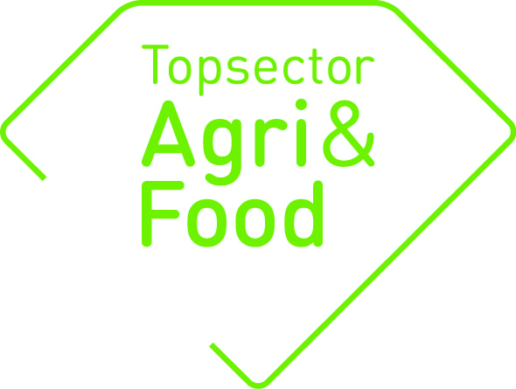

PPP annual report 2017
PPPs which have started under the direction of the top-sectors need to deliver an annual report regarding their research and financial progress. For reporting on research progress this format has to be applied. A separate format ‘PPP final report’ is available for PPPs that have finalized their work in 201 6- 2017.
The annual reports are entirely published on the TKI/topsector website(s), excluding the parts Approval coordinator/consortium, and Planning and progress. Please prevent the incorporation of confidential matter in the other parts.
For reporting financial progress a spreadsheet is available in which all projects per research organisation can be reported.
The PPP annual reports have to be submitted - pooled for each research organisation - before 1 April 2018 to the TKIs at info@tkitu.nl, or info@tki-agrifood.nl.

Format PPS-jaarrapportage topsectoren Agri&Food en Tuinbouw en Uitgangsmaterialen

General data
PPP number | TKI AF-14502
Title | What moves wasting muscle
Roadmap | Voeding en gezondheid
Project leader research (name + email address) | Lisette de Groot (lisette.degroot@wur.nl)
Coordinator (on behalf of private parties) | Michiel Sytsma (TiFN)
Contact person of government
Starting date | 1-1-2014
Final date | 31-12-2017
Brief description content (max. 4 lines) | Substantiation of the relationship between low muscle mass and chemotherapy-induced toxicities  A metabolic profile of mouse models related to changes in physical outcome parameters of muscle wasting  A metabolic comparison between human and mouse  Identification which pathways are conserved between mouse and human and could be targets for future interventions

Approval coordinator/consortium
The annual report has to be discussed with the coordinator/ consortium. The TKIs like to be informed regarding potential comments on the annual report.
The annual report is ………  by the coordinator on behalf of the consortium | approved  not approved
Potential comments regarding the annual report

Planning and progress (in case of any amendments to the project plan, please explain)
Is PPP running according to planning? | Yes, to be on the safe side measures are taken to guarantee continuity of the clinical study after the PhD promotion.
Any changes in the consortium/ the project partners? | No
Any delay and/or postponed delivery date? | No
Any bottlenecks have emerged? Give a brief description | No
Are there deviatons from the applied budget? | No
Do you expect a patent application from this PPP? | No

Highlights: give a brief description of the major results
Work package 1: paper is accepted in Journal of Cachexia Sarcopenia and Muscle Clinical reports.
Work package 2: paper is being written.
Work package 3: inclusion Comunex in progress.
Translational study on gene-expression mouse/human based on (partly) public big data in progress.

Number of delivered products in 2017 (give titles and/or description of products, or a link to the products on public websites)
Scientific articles | Reports | Articles professional journals | Lectures/workshops
Not applicable | Not applicable | Not applicable | Not applicable

Annex: Titles of deliverables or a link to products on a public website

